**DEFINITION OF BIOTECHNOLOGY:**

The term **Biotechnology** was introduced in 1917 by an Hungarian engineer, Karl Ereky. The term represents a fusion or an alliance between biology and technology. Ereky defined biotechnology as “**all lines of work by which products are produced from raw materials with the aid of living things** ”

**BRANCHES OF BIOTECHNOLOGY**

Biotechnology has rapidly emerged as an area of activities marked impact on all aspects of human welfare ranging from food process, production of resources, protecting environment, human health to quality of human life throughout the world. Some of the areas in which biotechnology is making a marked contribution are human and animal health, medicine, agriculture, oil mining, renewable energy, crime detection etc.

**Colour classification of Biotechnology**

**1.RED BIOTECHNOLOGY**

**(Medical/ Pharmaceutical)**

Red Biotechnology ( Medical) deals with diagnosis of various diseases; large scale production of various drugs and hormones such as human insulin and interferon; vaccines for chickenpox, rabies, polio etc. , and growth hormones, such as bovine. In the field of medical science, genetic engineering has helped in the large-scale production of hormones, blood serum proteins; in the development of antibiotics, and other medically useful products.

**2.WHITE BIOTECHNOLOGY ( Industrial)**

White biotechnology ( Industrial) deals with commercial production of various useful organic substances, such as acetic acid, citric acid, acetone, glycerine, etc., and antibiotics like penicillin, streptomycin, mitomycin, etc., through the use of microorganisms especially fungi and bacteria.

**3.GREEN BIOTECHNOLOGY (Agricultural)**

Agricultural biotechnology focuses on developing genetically modified plants to increase crop yields or introduce characteristics to those plants that provide them with an advantage growing in regions that place some kind of stress factor on the plant, namely weather and pests.

**4.YELLOW BIOTECHNOLOGY :**

Yellow biotechnology relates to the use of biotechnology in food production, for example, in making wine, cheese, and beer by fermentation.

**5.BLUE BIOTECHNOLOGY ( Marine):**

                        Blue biotechnology( Marine) based on the use of marine resources.

**Other branches of Biotechnology**

**1.ANIMAL BIOTECHNOLOGY :**

Animal Biotechnology deals with the development of transgenic animals for increased milk or meat production with resistance to various diseases. It also deals with in vitro fertilisation of eggs and transfer of embryos to the womb of female animals for further development.

**2.ENVIRONMENTAL BIOTECHNOLOGY :**

Environmental biotechnology deals with detoxification of waste and industrial effluents, treatment of sewage water, and control of plant diseases and insects through the use of biological agents, such as viruses, bacteria, fungi etc.

**3. PLANT BIOTECHNOLOGY :**

Plant Biotechnology is a combination of tissue culture and genetic engineering. It deals with development of transgenic plants with resistance to biotic and abiotic stress; development of haploids, embryo rescue, clonal multiplication, cryopreservation etc.

**4.MICROBIAL BIOTECHNOLOGY :**

Microbial Biotechnology enables methods and strategies for the production and uses of prokaryotes and eukaryotes microorganisms and archaea for the substance synthetics and use of microorganisms or their substance in synthesis and use of microorganisms.

**INTRODUCTION TO INDUSTRIAL BIOTECHNOLOGY**

Industrial biotechnology includes modern application of biotechnology for sustainable processing and production of chemical products , materials and fuels. Biotechnological processing uses enzymes and microorganisms to produce products that are useful to a broad range of industrial sectors including chemical and pharmaceutical, human and animal nutrition, pulp and paper, textiles, energy, materials and polymers using renewable raw materials. The types of industrial biotechnology are :

**1.Pharmaceutical Industry :**

They discover, develop and manufacture drugs and medications by public and private organisations. The modern era of the pharmaceutical industry of isolation of compounds, chemical synthesis and computer aided drug design.

**2.Food Industry:**

Food biotechnology is the application of modern biological techniques to the manufacture and processing of food products as well as food ingredients and food additives.

**Different types of food processing:**

**a. Fermentation:**

Fermentation is a process of synthesis of Breweries. Different yeast strains are used to make breweries at commercial level. Fermentation consists of  two steps :

1.Primary fermentation : Primary fermentation results in conversion of glucose into alcohol using yeast.

2. Secondary fermentation: Secondary fermentation uses bacteria and its product is lactic acid and this causes the rise in level of acidity.

**b.Brewing:**

Brewing is the practice of regulating the interaction between water, starch, yeast and hops so that the end result is what is called beer.

**c.Pasteurisation:**

Pasteurisation is a mild heat treatment in which food is heated to below 100 degree Celsius. It is used to minimise health hazards from the pathogenic microorganisms in low acid foods and to extend the shelf life.

**3.AGRICULTURAL INDUSTRY:**

Agro industries provide a means of converting raw materials into valuable added products while generating income and employment and contribution to overall economic development in both developed and developing countries.

**INTRODUCTION TO PETROLEUM BIOTECHNOLOGY SECTION, R&D DEPARTMENT   OIL INDIA LIMITED, DULIAJAN**

Oil India Limited (OIL) has developed new Biotechnology based technologies, to solve a wide array of its operational problems in an economical and ecologically sustainable manner. The key components in all these biotechnological interventions are living microorganisms or their metabolic products. Microorganisms being living organisms, require sophisticated infrastructure and technically skilled manpower for their isolation, activity elucidation, genomic & metabolic characterisation, scale-up for bio product formulation, viability assessment and monitoring during field implementation. Furthermore, the success rates of any biotechnological intervention in the E&P industry increases considerably if the microbial formulations are derived from the natural microflora of the sites in which they are intended to be used.

The companies are divided into three parts:

* **Upstream:**

Upstream companies are involved in identification/discovery and extraction of crude oil from under the earth surface. They conduct research, explore and set up oil wells, do the drilling to get access to the crude oil deposits and actively engage in extraction of crude oil. Some of the Upstream companies are :

1. Oil India Limited    2.Oil and Natural Gas Corporation Limited

* **Midstream:**

Midstream Companies refers to the transportation of crude or refined petroleum products, usually via pipeline, oil tanker, barge, truck or rail. The final destination is refineries which will then commence the downstream process.

* **Downstream :**

Downstream Companies are those that deal with the processing and delivery after the procurement of crude.It includes refining of oil and converting it to a final product that is sold to the customers. Some of the downstream companies are:

1. Indian Oil corporation Ltd.
2. Bharat Petroleum Limited

**MAJOR EQUIPMENTS IN PETROLEUM BIOTECHNOLOGY SECTION**

In addition to a dedicated team of scientists and standard equipment of any biotechnological research laboratory the state-of-the-art facility is equipped with advanced instrumentation for performing a variety of analysis in the field of Petroleum Biotechnology.

**A.Bench Scale Bioreactor :**

Mass scale liquid culture for optimisation of media and production of metabolites.

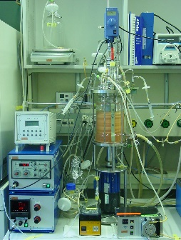

**B.Shake Incubator:**

Incubation of microbial culture with concomitant shaking for enhanced bio activity.

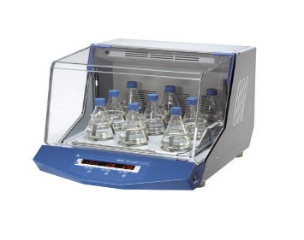

**C. Thermal Cycler :**

Amplification of DNA sequences using Polymerase Chain Reaction for characterisation of microbial strains.

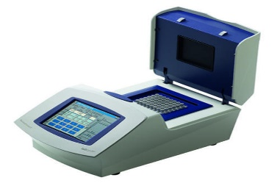

**D. Anaerobic Work Station :**

Isolation and culture of obligate  (strictly) anaerobic microbes.

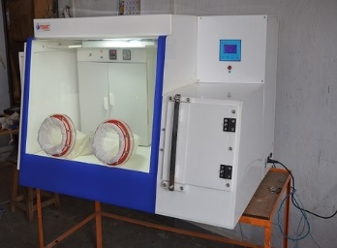

**D. Soxhlet Apparatus:** Solvent extraction of water insoluble components from biological    materials from soil and sludge.

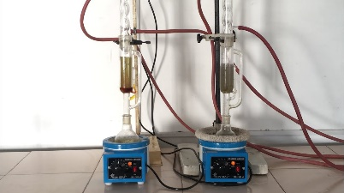

**F. HPLC and GC System:**Chromatographic analysis for characterisation of microbial products of interest from unknown and novel microbes.

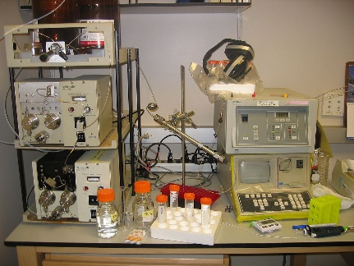

**INTRODUCTION TO BASIC MICROBIOLOGICAL TECHNIQUES:**

Microbiological techniques ate the techniques that are used for studying about microbes including bacteria, fungi and the protists. Mostly, they include the methodologies for conducting survey, culture, identify, stain, engineer and manipulate microbes.

The methodologies mostly involve techniques for culturing, identification, isolation, staining, and engineering these tiny organisms.

The microbial techniques are categorised into:

**1. ASEPTIC METHOD:**

Microorganisms are everywhere, and to study specific organisms, it’s essential to grow them in a strictly controlled lab environment. A complete sterile condition protects the pure microbial culture from contamination by other organisms entering through the air, water, or other unsterile sources.The aseptic methods are:

**A.Sterilisation:**

It’s the complete removal of all other microbial forms, including viruses, bacteria, fungus, spores, and other vegetative cells from the surface or the culture media. Based on the purpose of the sterilisation, the method is categorised into two groups:

* **Physical Methods:** It involves the killing of contaminants or microbial forms using   heat, sunlight, drying, filtration, or irradiation techniques (e.g., UV, infrared, gamma radiation, and X-ray).
* **Chemical Methods:** It utilises chemicals such as phenol (and any other related compounds), dyes, soaps, detergents, alcohol, gaseous compounds, and heavy metals and their compounds to destroy microorganisms.

**B. Disinfection:**Disinfection is the process of killing microbes or inhibiting their growth from inanimate objects or surfaces by using physical or chemical agents like phenol, chlorine, alcohol, and heavy metal and their compounds.

**C. Sanitization:** Sanitization is the complete elimination of all pathogenic and non-pathogenic microbes from surface tops to reduce contamination. It’s also employed in daily lives to sanitise hands or in restaurants, dairies, and breweries to remove microbes and prevent infection and contamination. It involves chlorine-based cleaners, alcohol-based cleaners, formaldehyde, and hydrogen peroxide.

**2. CULTURE MEDIA:** Microbes are grown or cultured in laboratories in culture media, which supply their nutritional requirements. These requirements vary for different microorganisms, thus a spectrum of culture medium recipes have been developed by scientists to obtain the desired microbial strain.

**A.Supportive Media:**Supportive media helps in the growth of wide varieties of microbes. Eg: LB media, Tryptic Soy Agar.

**B.Enriched Media:** Enriched media is used to grow fastidious growth of microorganisms and need special nutrients.EG: Blood Agar media.

**C.Selective Media:** Selective media will favour the growth of a particular microbe and suppress or inhibit the growth of others. Eg: EMB media, Mac Conkey media.

**D.Differential Media:** Differential Media helps to distinguish among different groups of bacteria by observing biological characteristics. Eg: EMB, Blood Agar.

**E.Complex Media :** Complex Media are added as supplements and didnt have a defined composition. Eg: Tryptone, Beef Extract, Yeast Extract

**3. INOCULATION:**

It’s a basic technique used in microbiology labs to place microbial cultures onto a culture medium. It’s performed using an apparatus, called inoculation loop, made of platinum or nichrome wire with a loop at its one end. It’s mainly used in streaking and culture plate techniques. The small sample picked up and transferred from the culture is known as inoculum.

**4. COMMON CULTURAL TECHNIQUES:**

**A. Streak plate method:** In Streak plate technique, an inoculation loop is dipped in a diluted microorganism suspension and streaked on the solid surface of the culture medium. The plate which gets streaked is known as the streak plate. The method is generally used to obtain individual bacteria colonies from a concentrated suspension or to prepare a pure culture of a bacterial strain.

**B.Spread plate method:** Spread plate method, a very small volume of the liquid suspension of the microorganism is poured on the solidified surface of the media-containing plate. Then, an L-shaped glass rod is used to spread the liquid evenly all over the plate surface. This is performed to obtain individual colonies of the microorganisms but can also count the number of the microbial population.

**C.Pour plate method:** Pour plate technique, is a serially diluted microorganism suspension is pipetted in a sterile Petri dish. Then, a liquified, cooled culture media is poured into the plate. After the media is solidified, the culture plate is incubated for specific bacterial growth. It’s performed to estimate the viable bacterial count in a microbial suspension.

**5. INCUBATION:**

After the microorganisms are inoculated in plates, the culture plates are sealed from base to lid using adhesive tape to prevent contamination. Then, the plates are kept in the incubator for the required time and temperature for the growth of the organisms. Furthermore, keeping the plates in an inverted position prevents the formation and fall of water droplets into the culture media.If it’s required to store the microbial samples for later experiments, the following storage techniques are used:

* Refrigeration
* Deep freezing
* Lyophilization
* Freezing in liquid nitrogen

**6. BACTERIAL ENUMERATION :**

Counting microbial colonies is an essential task in performing a range of experiments. Here are some enumerating techniques:

**A.Serial dilution:** It’s used to lower the concentration of bacteria to a required amount for the purpose of experimentation to culturing processes. It helps to count the number of microbial populations and perform experiments with the necessary number of microbial populations.

**B.Plate counts:** By applying the plate count method, it is possible to determine how many microbial colonies could potentially emerge under the given physical and chemical conditions, such as pH, temperature, available nutrients, and growth inhibitory compounds.

**C.Most probable number (MPN):** In this statistical technique, a broth is inoculated in a 10-fold dilution, predicting the number of viable microorganisms per volume in a given sample.

**D.Using spectrophotometer:** A spectrophotometer is used to estimate the growth of microorganisms in the culture with respect to time or at a certain time.

**7. IDENTIFICATION OF BACTERIA:**

Bacterial identification is an important application. For example, it’s used to know which microbe is involved in contamination and food spoilage, which has useful applications in human lives, and which microorganism caused the particular disease for correct diagnosis and treatment in hospitals. Microbes are identified by:

**1.MORPHOLOGY:** Morphology is the first step in the identification process where the microorganisms are assessed with the naked eye based on colony texture, shape, and size.

**2.STAINING TECHNIQUES:**Staining is a technique of identification that is done by staining microbes with certain chemicals and observing them under a microscope to assess their cell properties.

**A.Simple staining:** In simple staining method, bacteria are stained using a single reagent and identified based on their size, shape, and arrangement of cells.

**B.Differential staining:** In Differential staining method at least three chemical reagents are used to stain bacteria, and identification is done based on the colour the microorganism shows.

**C.Gram staining:**In gram staging certain chemical reagents are used to differentiate two principal groups of bacteria, gram-positive and gram-negative.

**3.MICROSCOPY TECHNIQUES:**Microscopy technique is used forSome microorganisms like viruses that can not be identified using a simple microscope, as in the case of other microorganisms. Therefore, a high-throughput electron microscope is required to identify them.

**3.BIOCHEMICAL TESTS:** Biochemical tests are ofDifferent tests, such as oxidase test, catalase test, indole test, and Dnase test are performed to differentiate microorganisms based on their enzymatic activities.

**4.MOTILITY:**The motility capacity of microorganisms is assessed to distinguish them from other microorganisms and identify their groups.